Mixed Wavy Shapes

Definition
# Source: AI Source: Provided by: [Data Path: Persons Table -> ID Column: 1, Name_En Column: Motasem Essam] -> From: [ChatGPT] on [7/25/2026]
A Mixed Wavy Shape is a wavy shape or wavy arrangement that combines different wavy characteristics, patterns, or geometric properties within the same overall form.
For example, different portions of a wavy boundary may have different:
- Wave sizes
- Wave frequencies
- Curvatures
- Regularity
- Symmetry
- Geometric styles
The term mixed wavy shape is primarily descriptive, rather than a universally standardized mathematical classification.
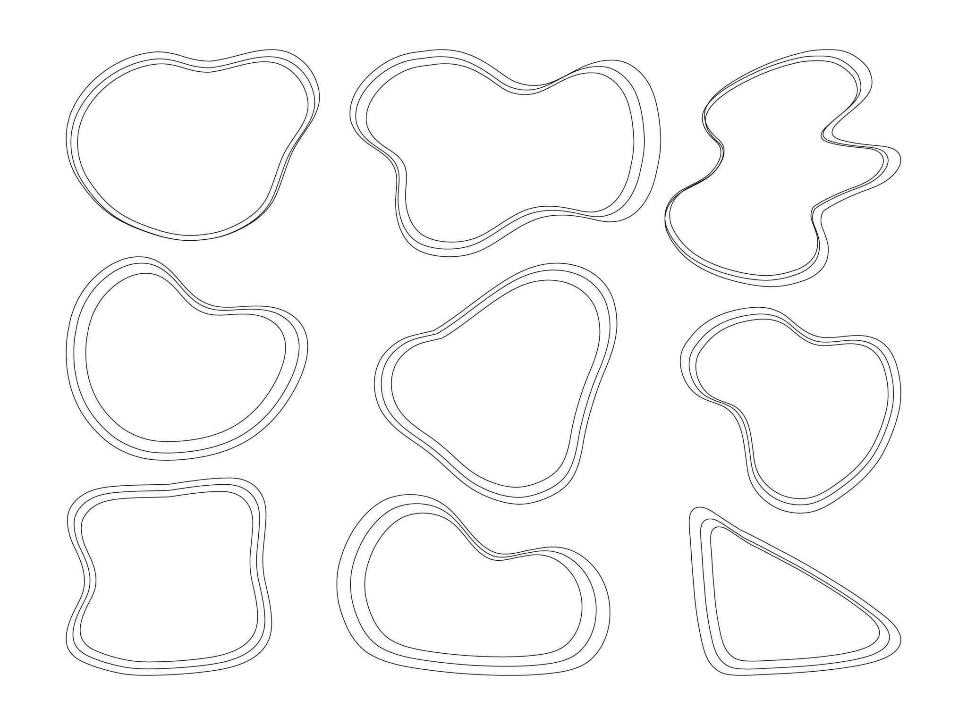
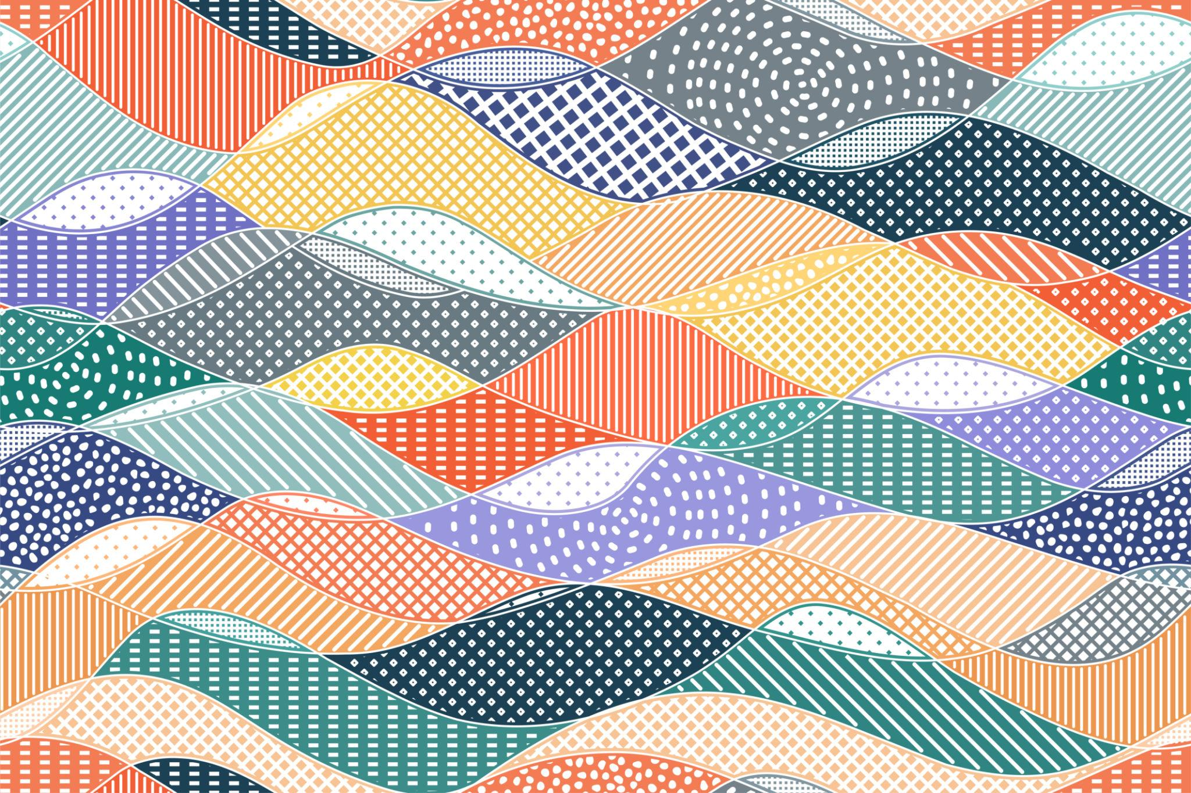
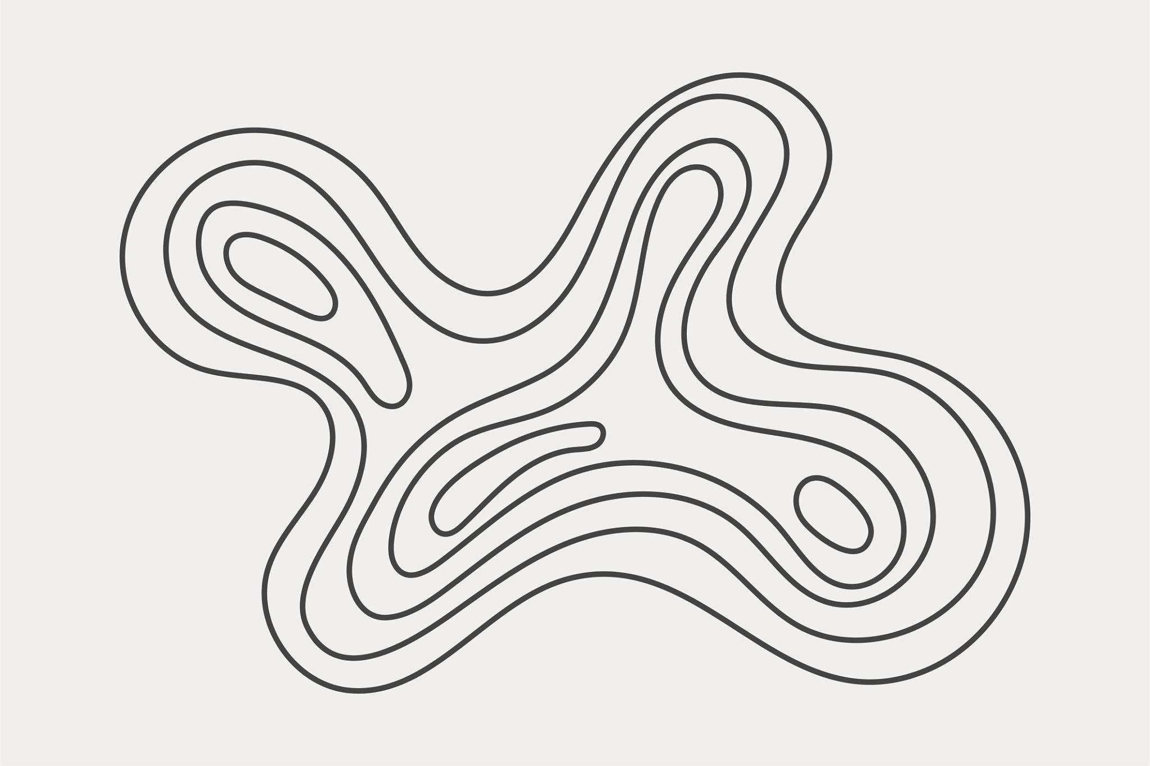
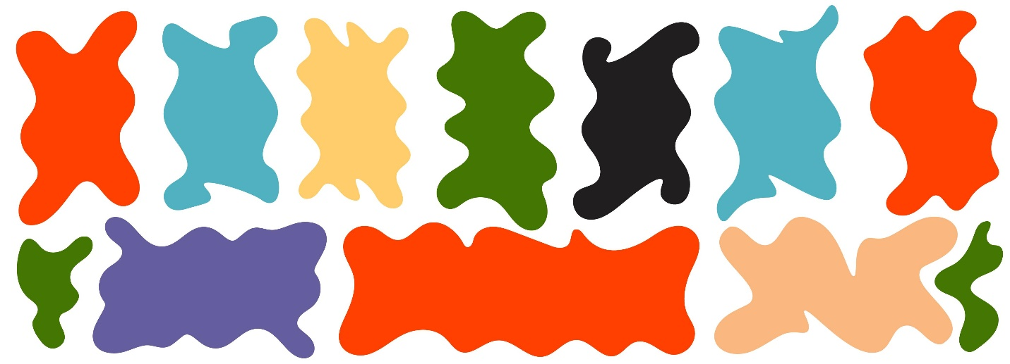
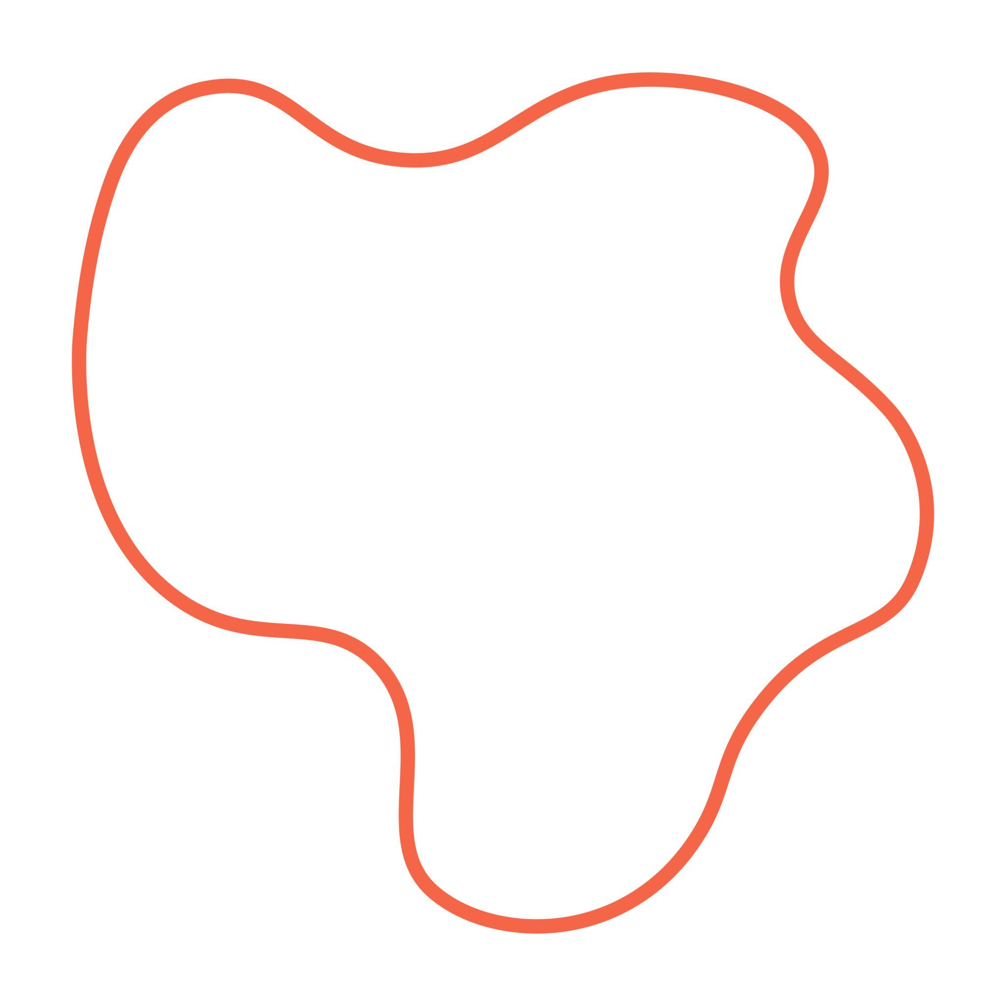

Fundamental Concept
# Source: AI Source: Provided by: [Data Path: Persons Table -> ID Column: 1, Name_En Column: Motasem Essam] -> From: [ChatGPT] on [7/25/2026]
The fundamental idea is combination.
Instead of the entire shape following one consistent wavy characteristic, different sections can exhibit different characteristics.
For example:
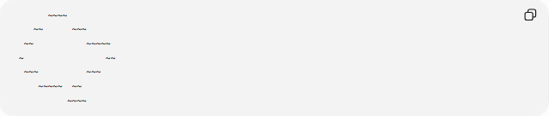
~~~~
~~ ~~~
~~ ~~~~~
~ ~~
~~~ ~~~
~~~~~ ~~
~~~~
One part may have small, closely spaced waves, while another part may have larger, widely spaced waves.
A mixed wavy shape can therefore be described by combining multiple classifications.

Main Characteristics
# Source: AI Source: Provided by: [Data Path: Persons Table -> ID Column: 1, Name_En Column: Motasem Essam] -> From: [ChatGPT] on [7/25/2026]
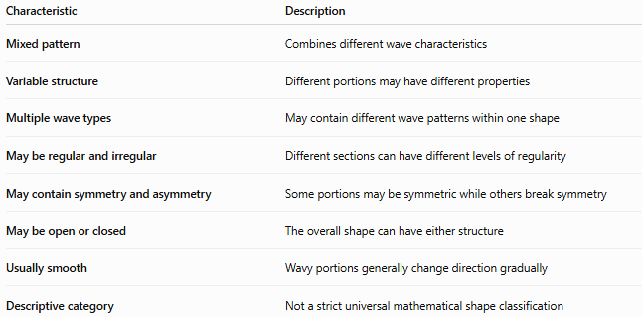
Characteristic | Description
Mixed pattern | Combines different wave characteristics
Variable structure | Different portions may have different properties
Multiple wave types | May contain different wave patterns within one shape
May be regular and irregular | Different sections can have different levels of regularity
May contain symmetry and asymmetry | Some portions may be symmetric while others break symmetry
May be open or closed | The overall shape can have either structure
Usually smooth | Wavy portions generally change direction gradually
Descriptive category | Not a strict universal mathematical shape classification

Basic Structure
# Source: AI Source: Provided by: [Data Path: Persons Table -> ID Column: 1, Name_En Column: Motasem Essam] -> From: [ChatGPT] on [7/25/2026]
A mixed wavy shape can be thought of as a combination of several curve sections:
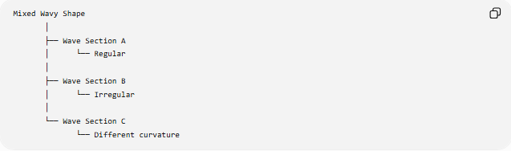
Mixed Wavy Shape
│
├── Wave Section A
│ └── Regular
│
├── Wave Section B
│ └── Irregular
│
└── Wave Section C
└── Different curvature
Mathematically, a mixed curve can be represented using different functions over different intervals.
For example:
$$f\left(x\right)=\left\{\begin{matrix}f_{1}\left(x\right), & a≤x<b \\ f_{2}\left(x\right), & b≤x<c \\ f_{3}\left(x\right), & c≤x≤d\end{matrix}\right.$$
Each function can describe a different portion of the overall wavy shape.

Types of Mixed Wavy Shapes

1-Mixed Regular–Irregular Wavy Shapes
# Source: AI Source: Provided by: [Data Path: Persons Table -> ID Column: 1, Name_En Column: Motasem Essam] -> From: [ChatGPT] on [7/25/2026]
A Mixed Regular–Irregular Wavy Shape contains both:
- Regular/repeating wave sections.
- Irregular/non-uniform wave sections.
For example:
Regular section Irregular section
~~~ ~~~ ~~~ ~~~~ ~~~ ~~~~~
The first section may repeat consistently while the second changes in amplitude or spacing.
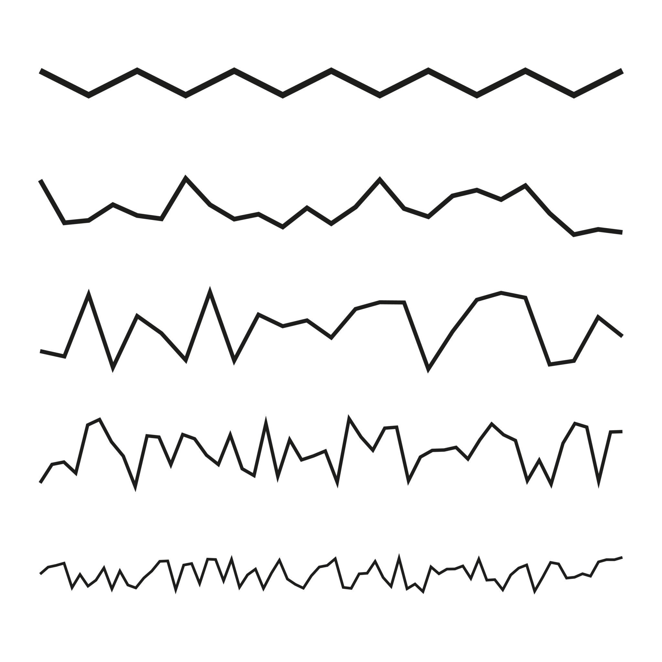
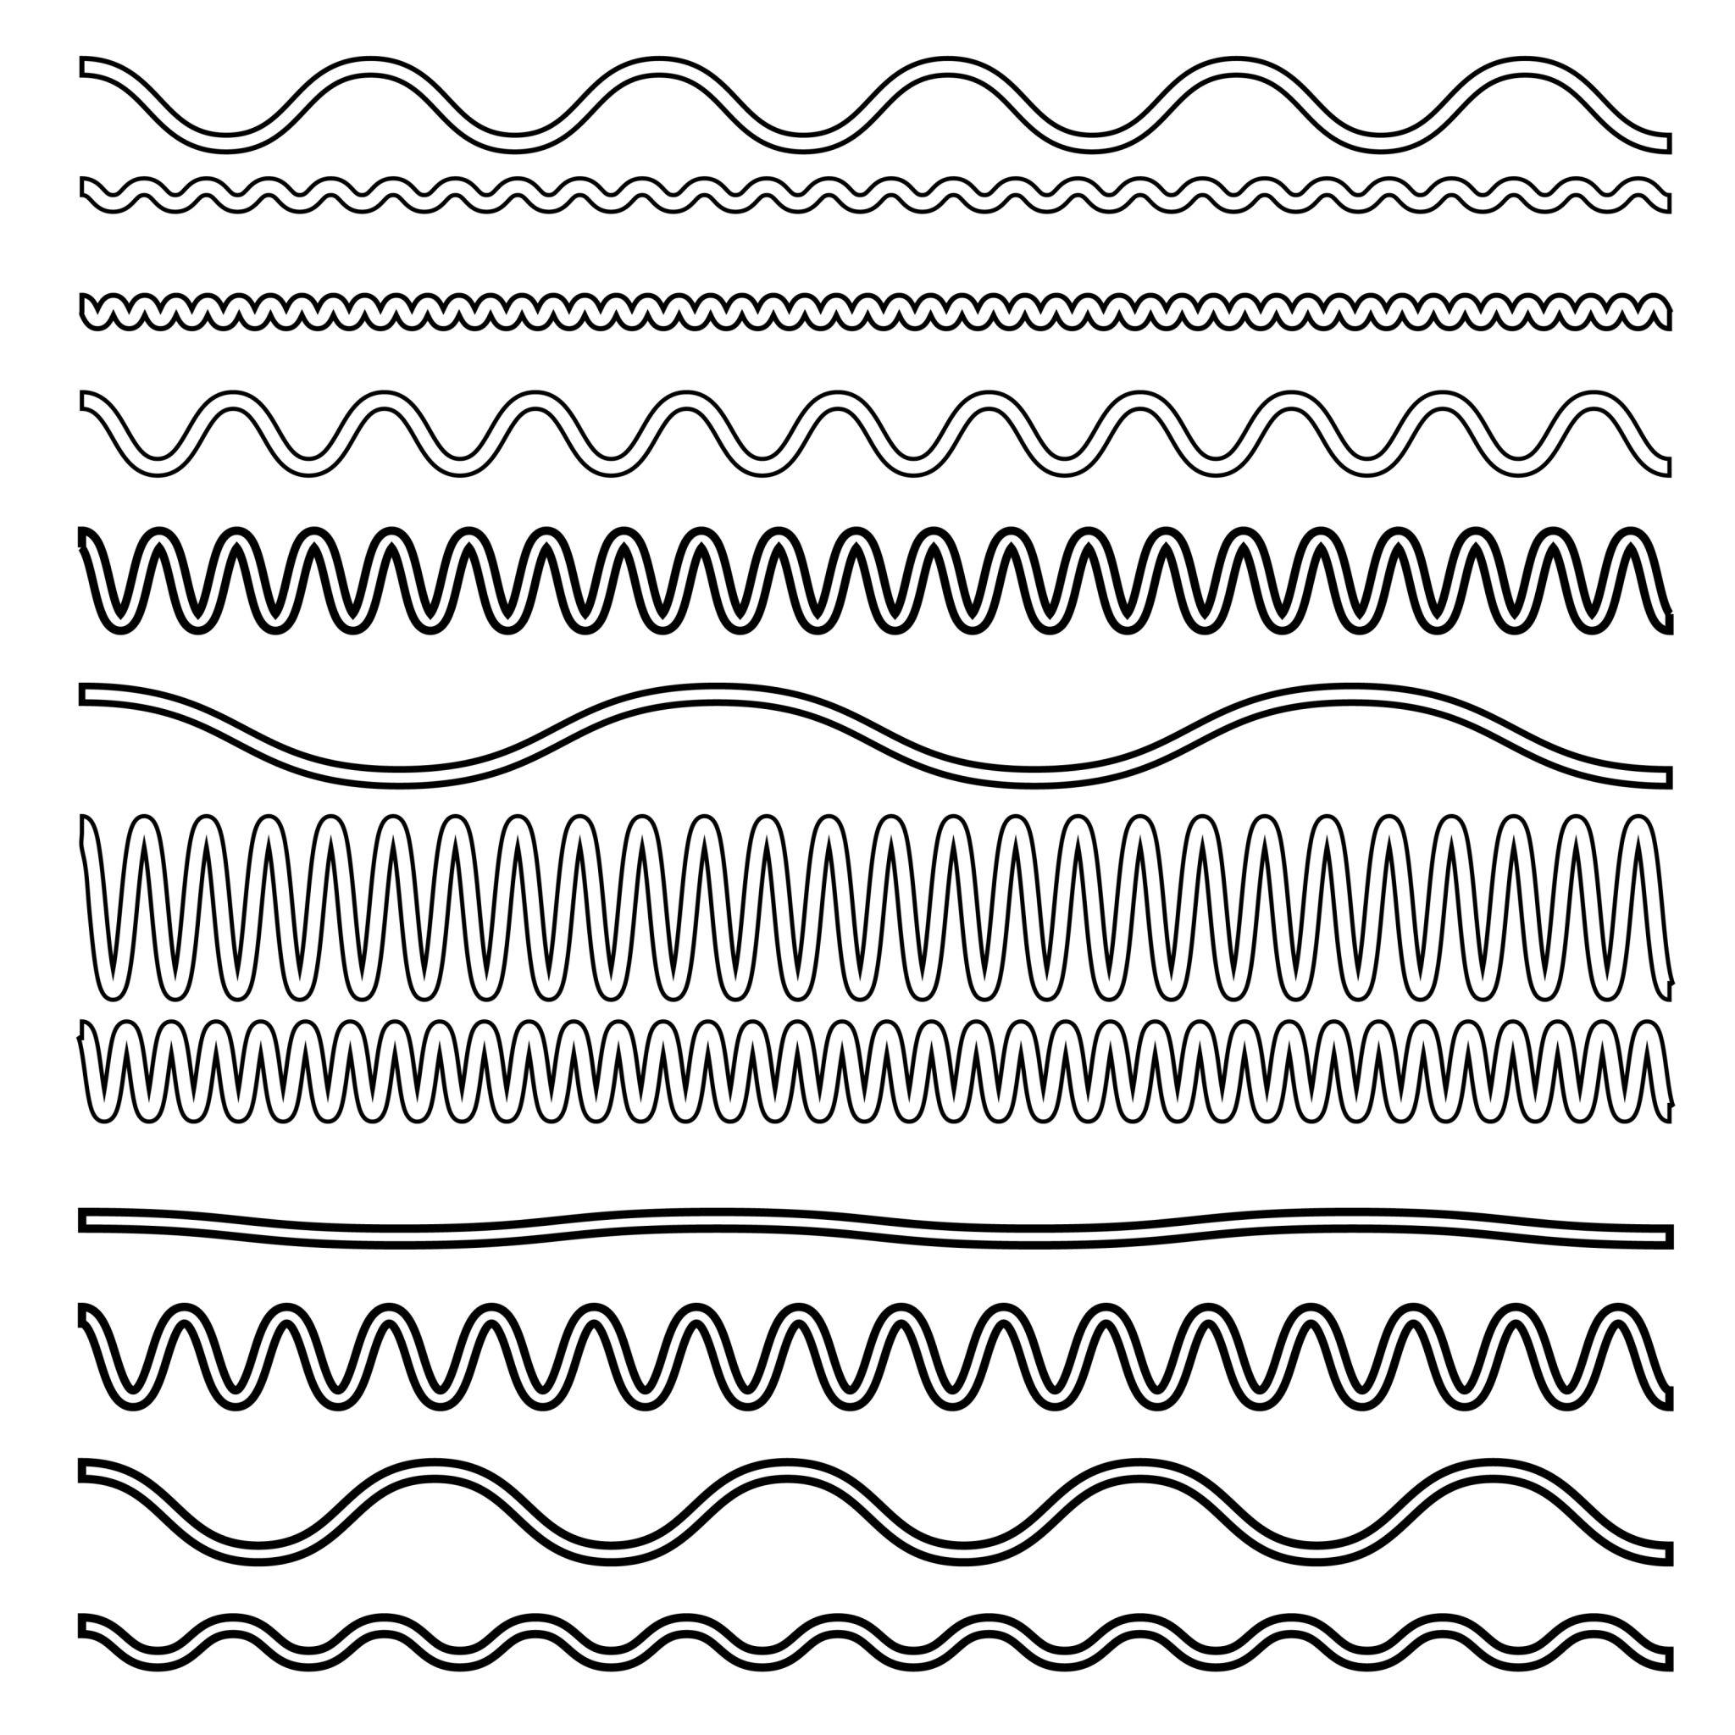
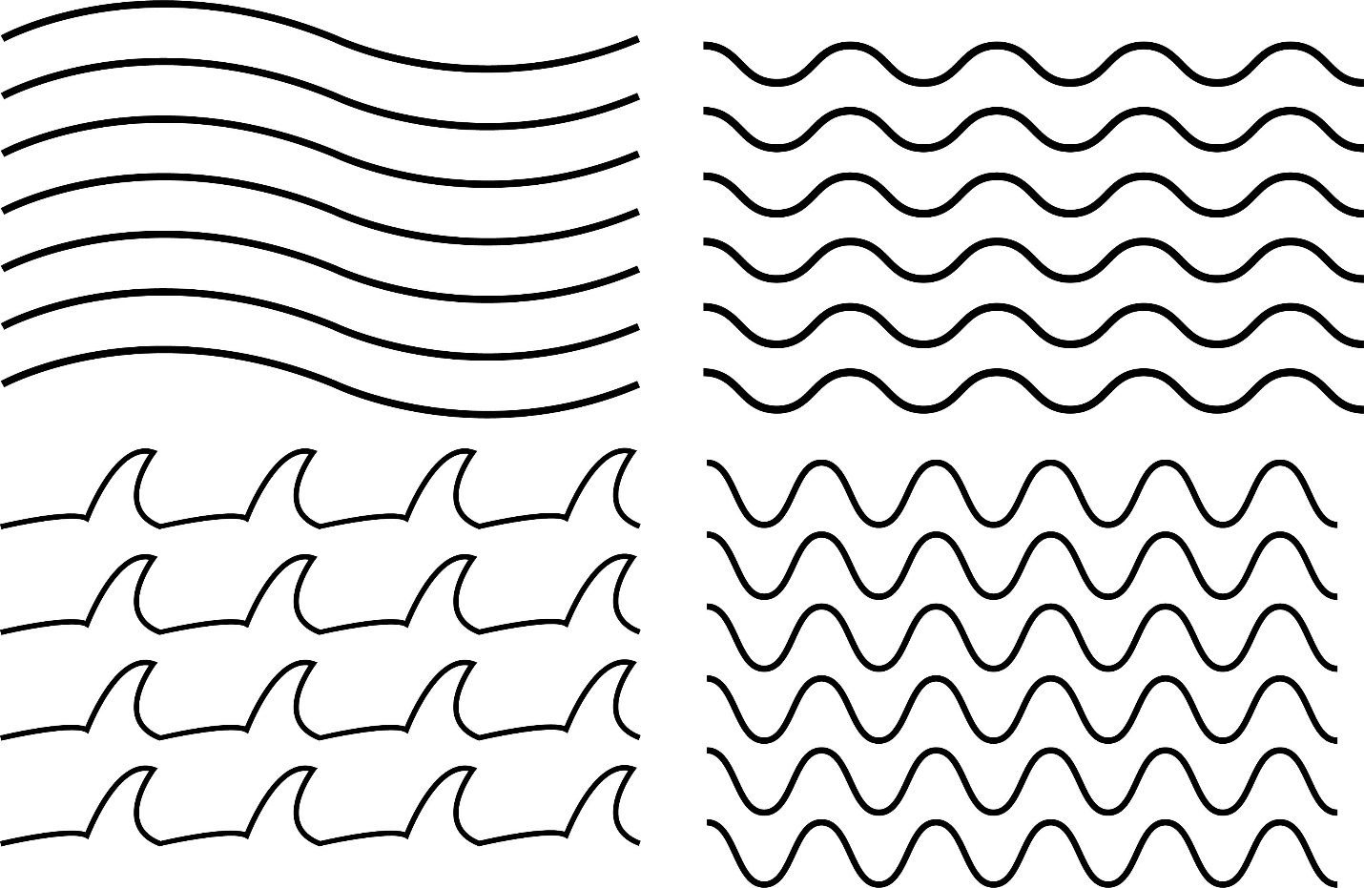

2-Mixed Symmetric–Asymmetric Wavy Shapes
# Source: AI Source: Provided by: [Data Path: Persons Table -> ID Column: 1, Name_En Column: Motasem Essam] -> From: [ChatGPT] on [7/25/2026]
A Mixed Symmetric–Asymmetric Wavy Shape contains portions that exhibit symmetry and portions that do not.
For example, one side of a shape may mirror another section, while an additional wave breaks the overall symmetry.
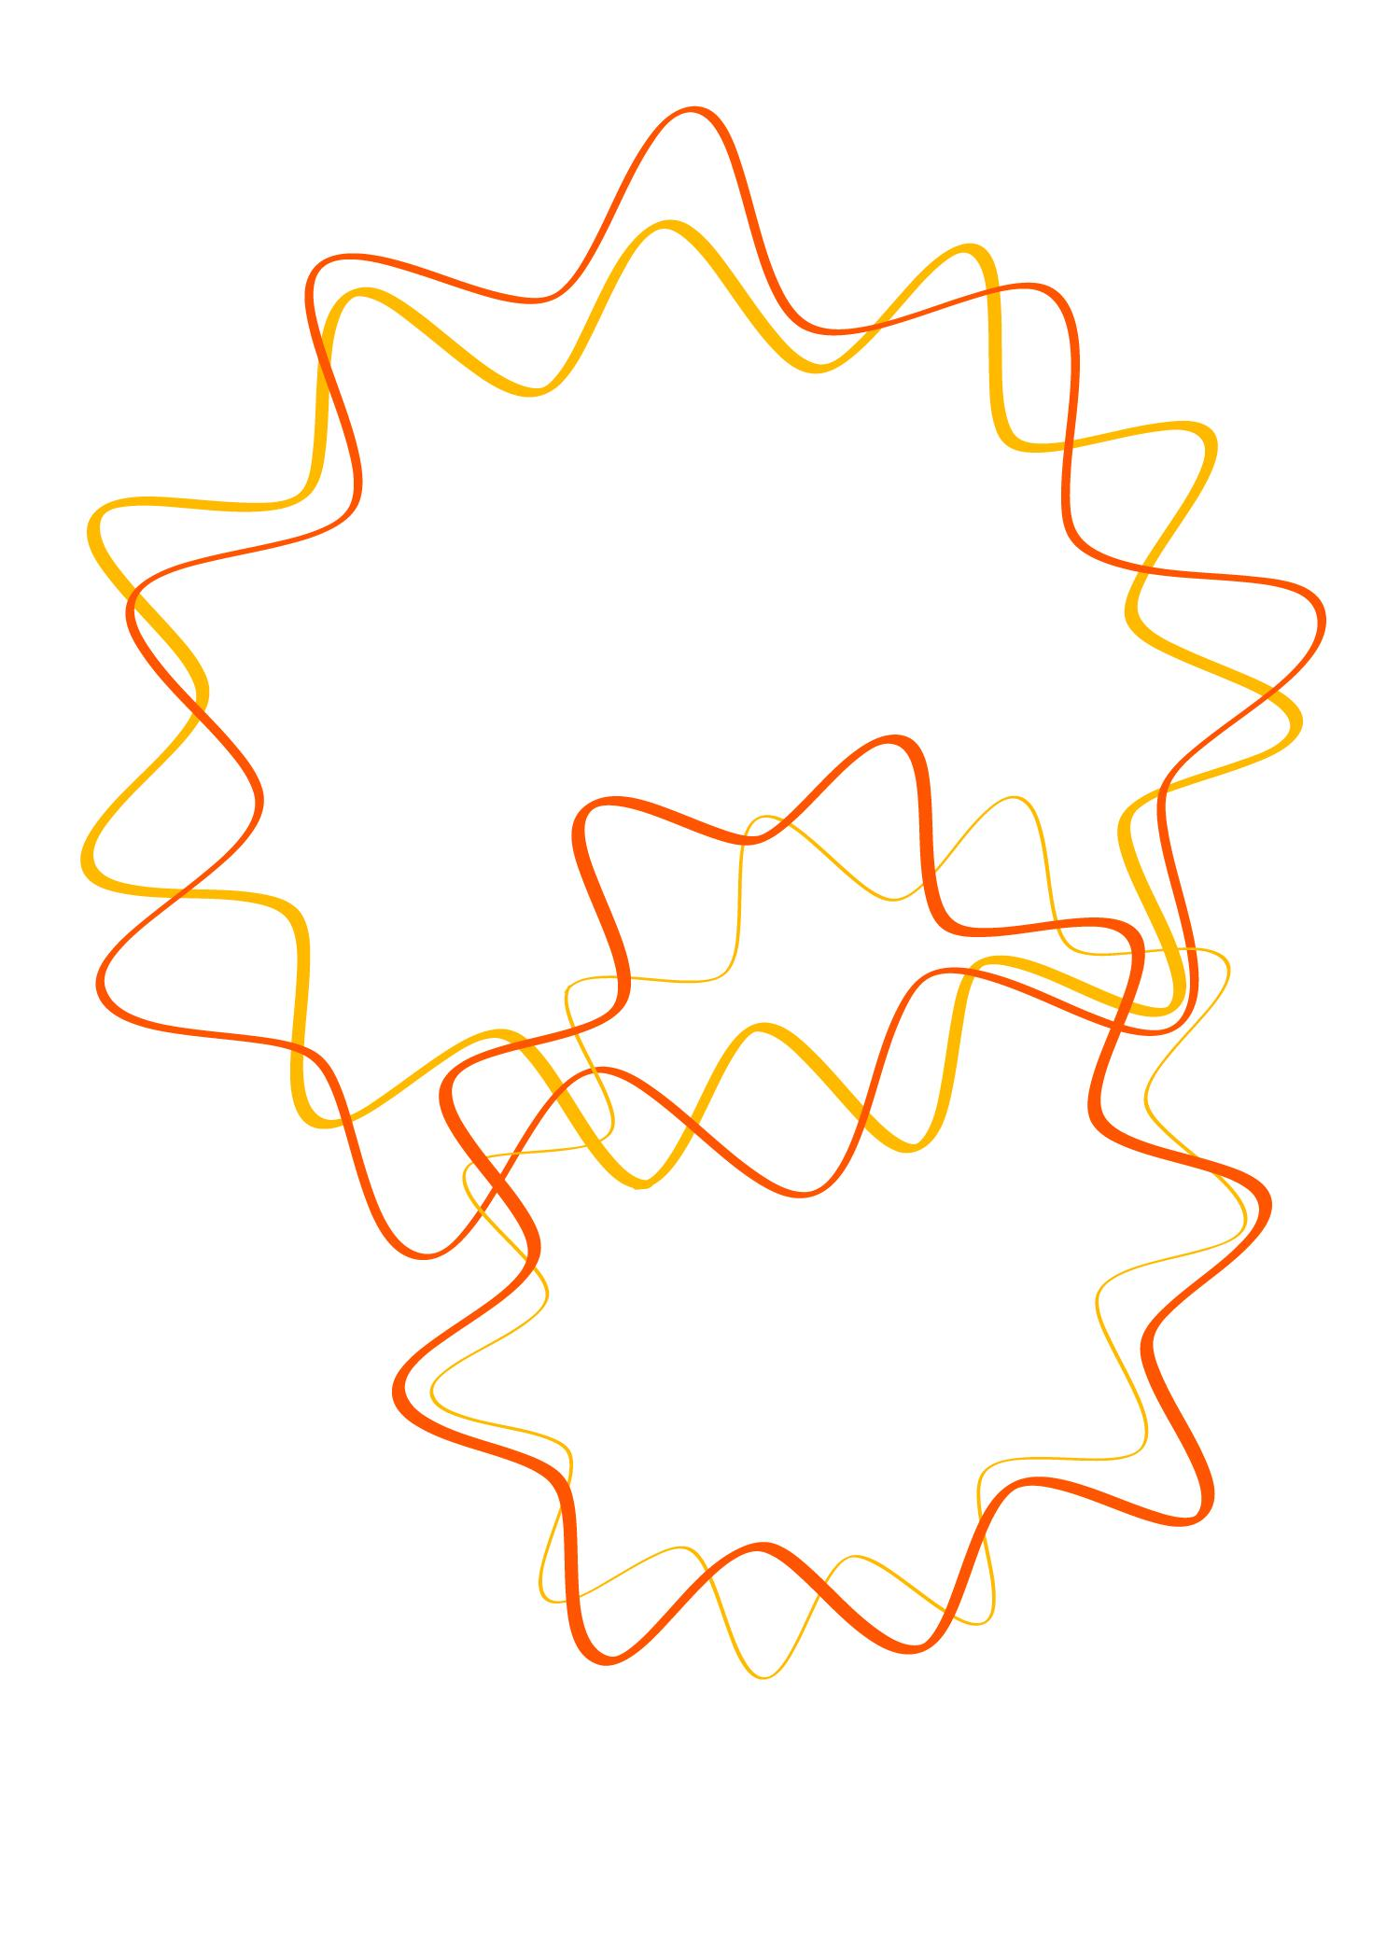
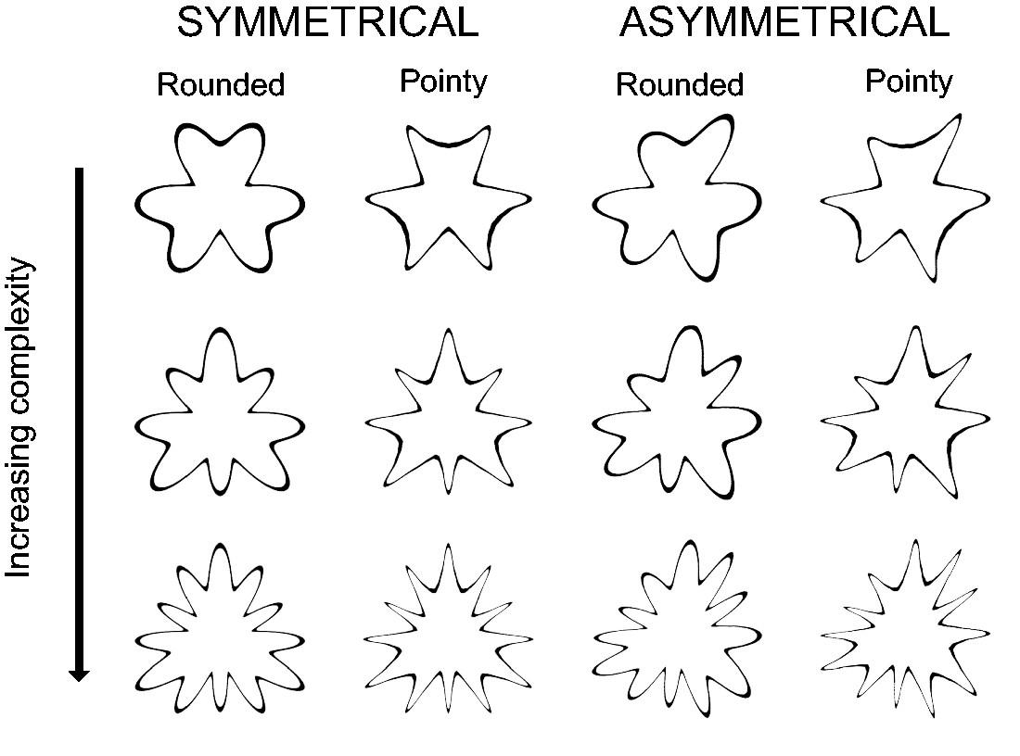

3-Mixed Frequency Wavy Shapes
# Source: AI Source: Provided by: [Data Path: Persons Table -> ID Column: 1, Name_En Column: Motasem Essam] -> From: [ChatGPT] on [7/25/2026]
A Mixed Frequency Wavy Shape contains wave sections with different frequencies.
For example:
Low frequency: ~~~~~ ~~~~~
High frequency: ~~~ ~~~ ~~~ ~~~
Mathematically, different sections may be described by:
$$y=A_{1}sin⁡\left(B_{1}x\right)$$
and
$$y=A_{2}sin⁡\left(B_{2}x\right)$$
where
$$B_{1}≠B_{2}$$

4-Mixed Amplitude Wavy Shapes
# Source: AI Source: Provided by: [Data Path: Persons Table -> ID Column: 1, Name_En Column: Motasem Essam] -> From: [ChatGPT] on [7/25/2026]
A Mixed Amplitude Wavy Shape has waves with different amplitudes.
For example:
small waves: ~~~ ~~~ ~~~
large waves: ~~~~~~~~ ~~~~~~~~
A variable-amplitude model can be written as:
$$y=A\left(x\right)sin⁡\left(ϕ\left(x\right)\right)$$
where $A\left(x\right)$changes along the curve.
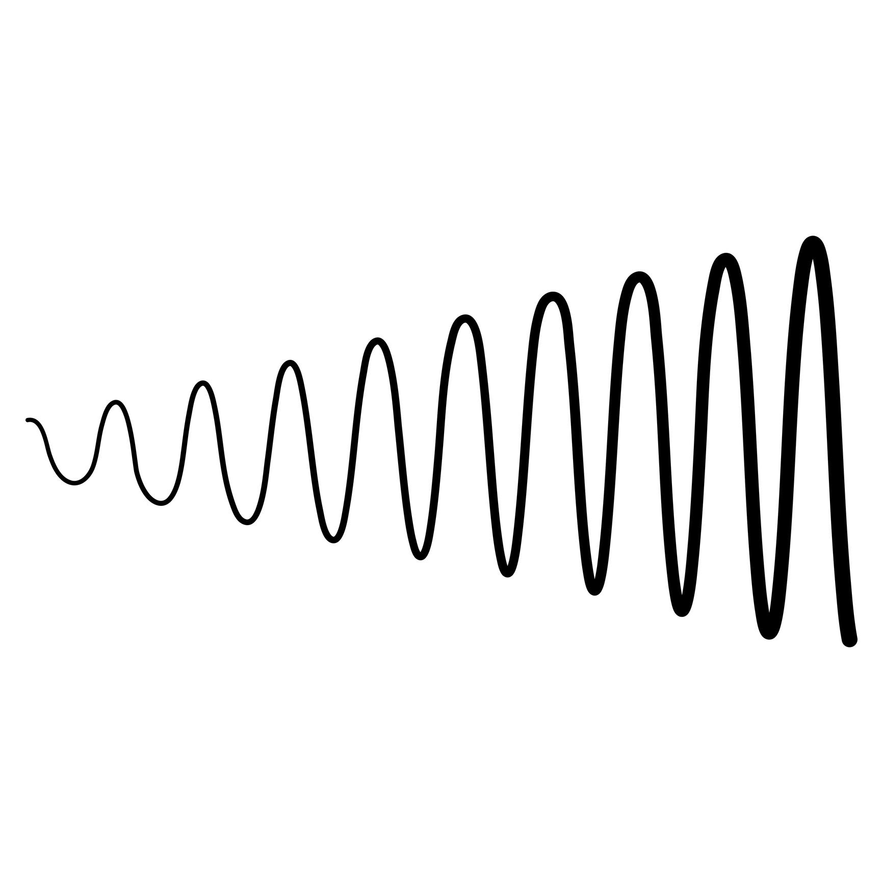
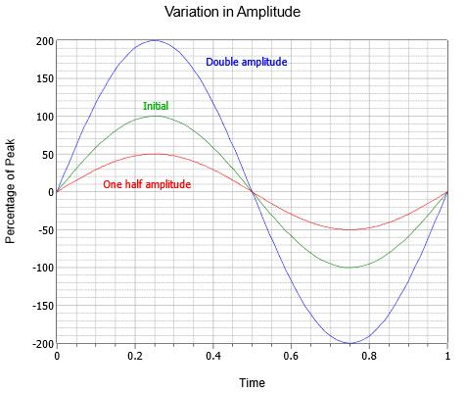
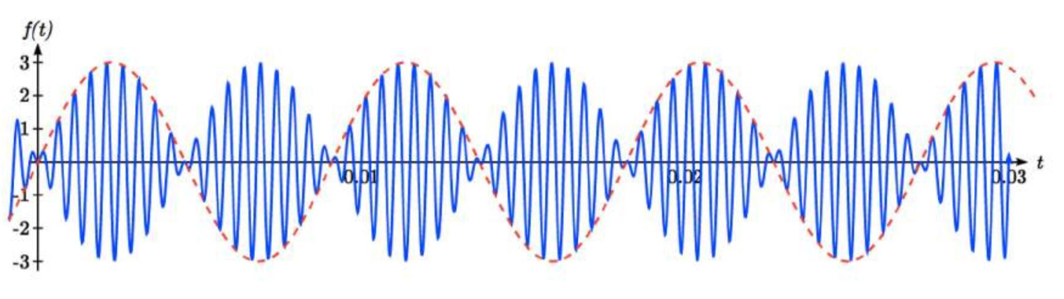

5-Mixed Curvature Wavy Shapes
# Source: AI Source: Provided by: [Data Path: Persons Table -> ID Column: 1, Name_En Column: Motasem Essam] -> From: [ChatGPT] on [7/25/2026]
A Mixed Curvature Wavy Shape contains portions with different degrees of curvature.
One portion may have broad gentle curves while another contains tighter curves.
The curvature of a plane curve can be expressed generally as:
$$κ=\frac{∣x^{'}y^{''}-y^{'}x^{''}∣}{{\left(x^{'2}+y^{'2}\right)}^{3/2}}$$
Thus, different sections can have different values of $κ$.

6-Mixed Open Wavy Arrangements
# Source: AI Source: Provided by: [Data Path: Persons Table -> ID Column: 1, Name_En Column: Motasem Essam] -> From: [ChatGPT] on [7/25/2026]
A Mixed Open Wavy Arrangement contains multiple open wavy components or sections.
For example:
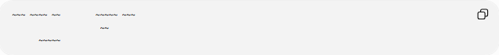
~~~ ~~~~ ~~ ~~~~~ ~~~
~~
~~~~~
This should be understood as an arrangement of multiple open components, rather than one single connected open curve.

7-Mixed Closed Wavy Shapes
# Source: AI Source: Provided by: [Data Path: Persons Table -> ID Column: 1, Name_En Column: Motasem Essam] -> From: [ChatGPT] on [7/25/2026]
A Mixed Closed Wavy Shape has a closed boundary containing different wave characteristics.
For example, one part of the boundary may have small regular waves while another part has larger irregular waves.
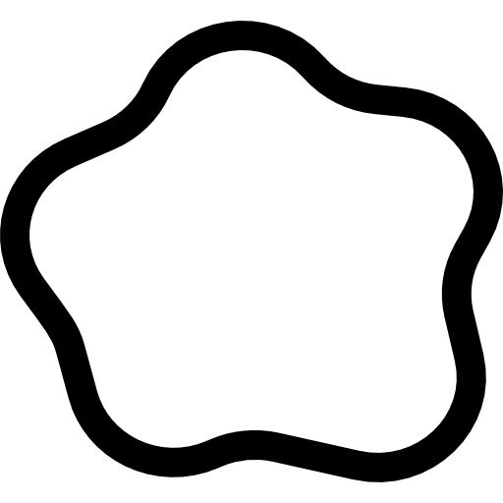
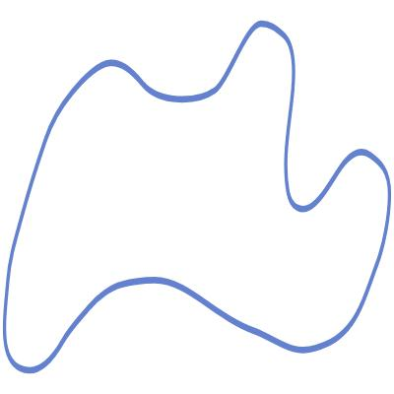
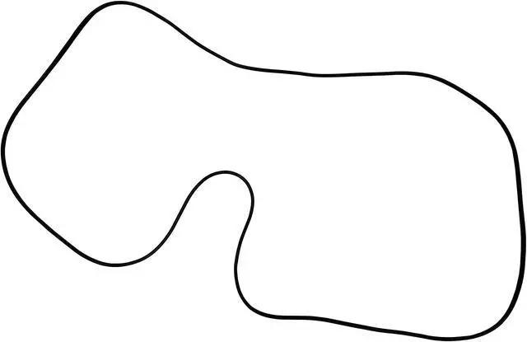

Mathematical Properties

Piecewise Representation
# Source: AI Source: Provided by: [Data Path: Persons Table -> ID Column: 1, Name_En Column: Motasem Essam] -> From: [ChatGPT] on [7/25/2026]
A mixed wavy curve can be modeled using piecewise functions:
$$f\left(x\right)=\left\{\begin{matrix}f_{1}\left(x\right), & x∈I_{1} \\ f_{2}\left(x\right), & x∈I_{2} \\ ⋮ & \\ f_{n}\left(x\right), & x∈I_{n}\end{matrix}\right.$$
where each interval $I_{i}$represents a different section of the shape.

Continuity
# Source: AI Source: Provided by: [Data Path: Persons Table -> ID Column: 1, Name_En Column: Motasem Essam] -> From: [ChatGPT] on [7/25/2026]
If the different sections are joined smoothly, their values should match at the joining point.
For two sections meeting at $x=c$:
$$f_{1}\left(c\right)=f_{2}\left(c\right)$$
For a smoother transition, their first derivatives can also match:
$$f_{1}^{'}\left(c\right)=f_{2}^{'}\left(c\right)$$
This helps prevent a sharp corner at the connection.

Arc Length
# Source: AI Source: Provided by: [Data Path: Persons Table -> ID Column: 1, Name_En Column: Motasem Essam] -> From: [ChatGPT] on [7/25/2026]
For a parametric mixed curve:
$$r\left(t\right)=\left(x , \left(t\right)y\left(t\right)\right)$$
the total length is:
$$L=\int_{a}^{b}{\sqrt{{\left(\frac{dx}{dt}\right)}^{2}+{\left(\frac{dy}{dt}\right)}^{2}}} dt$$
If the curve consists of separate sections, the total length can be expressed as:
$$L=L_{1}+L_{2}+⋯+L_{n}$$

Enclosed Area
# Source: AI Source: Provided by: [Data Path: Persons Table -> ID Column: 1, Name_En Column: Motasem Essam] -> From: [ChatGPT] on [7/25/2026]
If the mixed wavy shape is closed, its enclosed area can be calculated using:
$$A=\frac{1}{2}\oint{(}\left.x dy-y dx\right)$$
The mixed nature of the boundary does not prevent area calculation.

Mixed Wavy Shapes vs Regular Wavy Shapes
# Source: AI Source: Provided by: [Data Path: Persons Table -> ID Column: 1, Name_En Column: Motasem Essam] -> From: [ChatGPT] on [7/25/2026]
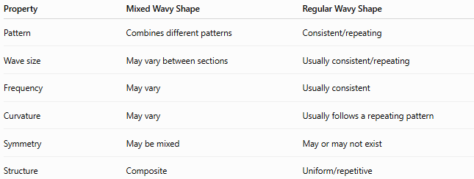
Property | Mixed Wavy Shape | Regular Wavy Shape
Pattern | Combines different patterns | Consistent/repeating
Wave size | May vary between sections | Usually consistent/repeating
Frequency | May vary | Usually consistent
Curvature | May vary | Usually follows a repeating pattern
Symmetry | May be mixed | May or may not exist
Structure | Composite | Uniform/repetitive

Mixed Wavy Shapes vs Irregular Wavy Shapes
# Source: AI Source: Provided by: [Data Path: Persons Table -> ID Column: 1, Name_En Column: Motasem Essam] -> From: [ChatGPT] on [7/25/2026]
These terms are related but not identical.
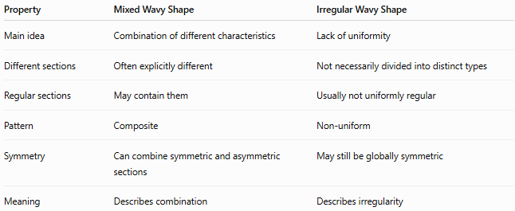
Property | Mixed Wavy Shape | Irregular Wavy Shape
Main idea | Combination of different characteristics | Lack of uniformity
Different sections | Often explicitly different | Not necessarily divided into distinct types
Regular sections | May contain them | Usually not uniformly regular
Pattern | Composite | Non-uniform
Symmetry | Can combine symmetric and asymmetric sections | May still be globally symmetric
Meaning | Describes combination | Describes irregularity
For example:
A shape containing a regular wave section and an irregular wave section is mixed.

Mixed Wavy Shapes vs Mixed Zigzag Shapes
# Source: AI Source: Provided by: [Data Path: Persons Table -> ID Column: 1, Name_En Column: Motasem Essam] -> From: [ChatGPT] on [7/25/2026]
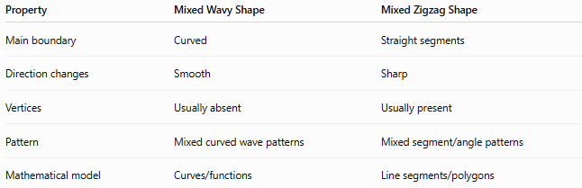
Property | Mixed Wavy Shape | Mixed Zigzag Shape
Main boundary | Curved | Straight segments
Direction changes | Smooth | Sharp
Vertices | Usually absent | Usually present
Pattern | Mixed curved wave patterns | Mixed segment/angle patterns
Mathematical model | Curves/functions | Line segments/polygons
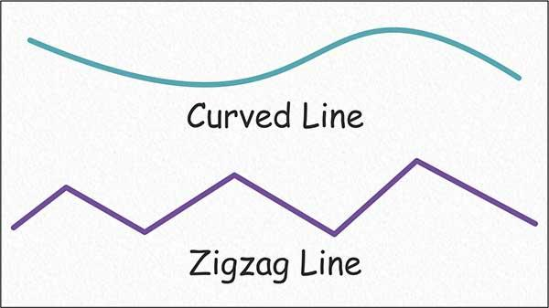
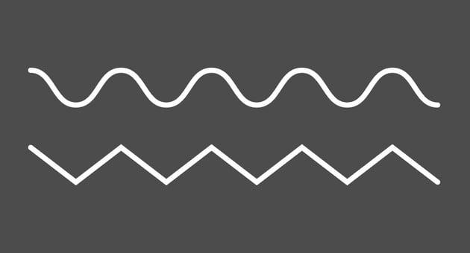
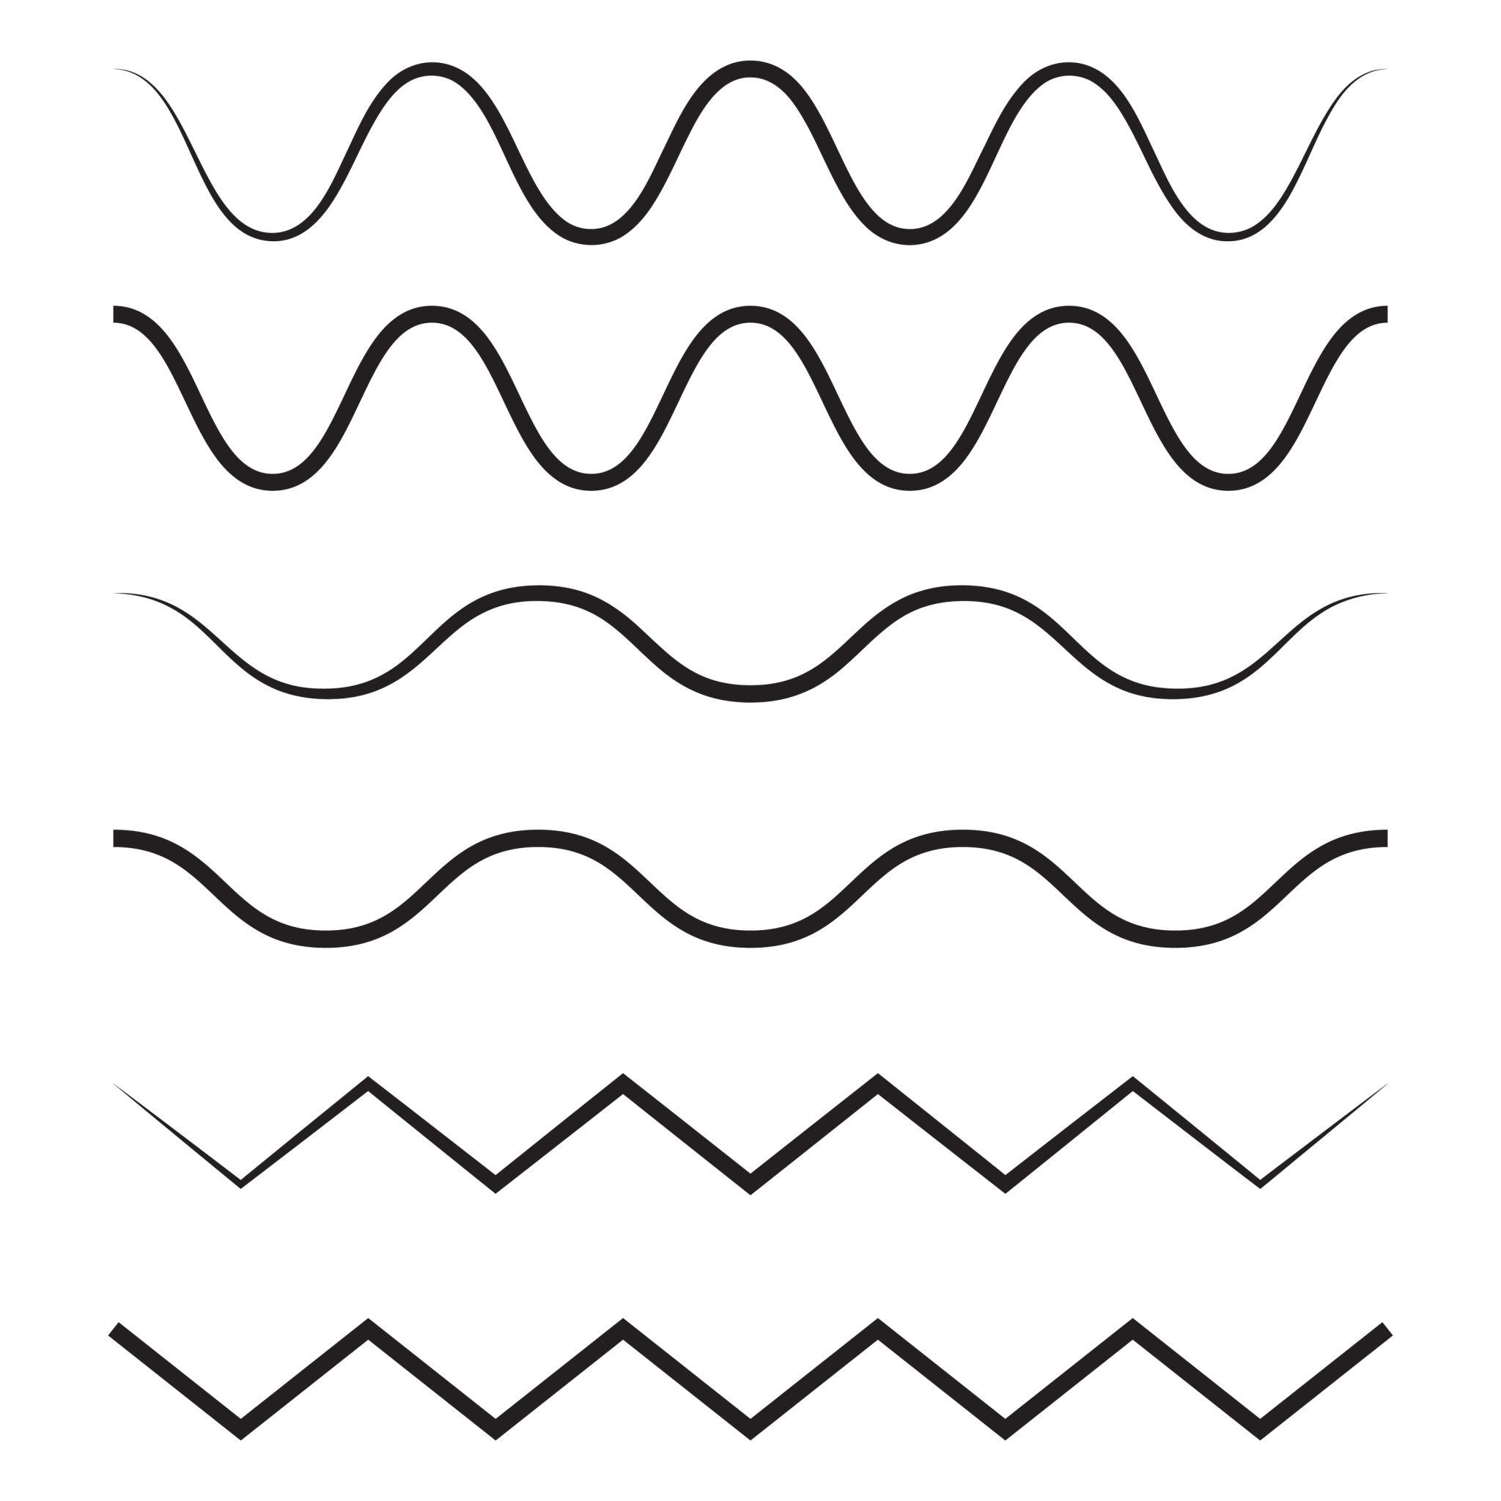

Examples
# Source: AI Source: Provided by: [Data Path: Persons Table -> ID Column: 1, Name_En Column: Motasem Essam] -> From: [ChatGPT] on [7/25/2026]
Examples of mixed wavy shapes include:
- A curve containing both large and small waves.
- A boundary combining regular and irregular wave sections.
- A shape with different wave frequencies in different regions.
- A closed outline with different wave amplitudes around its boundary.
- A shape with symmetric sections and asymmetric sections.
- A freeform curve combining several types of curvature.
- A composite arrangement containing multiple wavy components.

Classification Summary
# Source: AI Source: Provided by: [Data Path: Persons Table -> ID Column: 1, Name_En Column: Motasem Essam] -> From: [ChatGPT] on [7/25/2026]
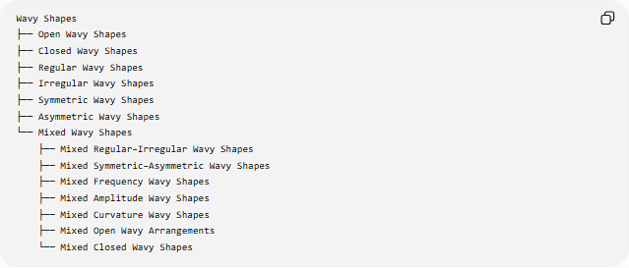
Wavy Shapes
├── Open Wavy Shapes
├── Closed Wavy Shapes
├── Regular Wavy Shapes
├── Irregular Wavy Shapes
├── Symmetric Wavy Shapes
├── Asymmetric Wavy Shapes
└── Mixed Wavy Shapes
├── Mixed Regular–Irregular Wavy Shapes
├── Mixed Symmetric–Asymmetric Wavy Shapes
├── Mixed Frequency Wavy Shapes
├── Mixed Amplitude Wavy Shapes
├── Mixed Curvature Wavy Shapes
├── Mixed Open Wavy Arrangements
└── Mixed Closed Wavy Shapes
Important Classification Note
Mixed Wavy Shapes are best treated as a descriptive category rather than a strict mathematical class.
The classifications can overlap:
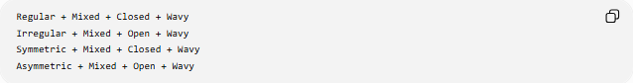
Regular + Mixed + Closed + Wavy
Irregular + Mixed + Open + Wavy
Symmetric + Mixed + Closed + Wavy
Asymmetric + Mixed + Open + Wavy

Key Points
# Source: AI Source: Provided by: [Data Path: Persons Table -> ID Column: 1, Name_En Column: Motasem Essam] -> From: [ChatGPT] on [7/25/2026]
- A Mixed Wavy Shape combines different wavy characteristics within one overall form or arrangement.
- Different sections can have different amplitudes, frequencies, spacing, or curvature.
- A mixed shape can combine regular and irregular sections.
- It can also combine symmetric and asymmetric characteristics.
- Mixed wavy shapes can be open or closed.
- A closed mixed wavy shape encloses a region.
- Piecewise functions are useful for mathematically describing different sections.
- Mixed describes a combination of characteristics; it does not simply mean irregular.

Conclusion
# Source: AI Source: Provided by: [Data Path: Persons Table -> ID Column: 1, Name_En Column: Motasem Essam] -> From: [ChatGPT] on [7/25/2026]
A Mixed Wavy Shape is a descriptive type of wavy form in which different sections or components exhibit different geometric or wave characteristics. It may combine regular and irregular patterns, different amplitudes or frequencies, different curvatures, or different symmetry properties. Therefore, mixedness describes the combination of characteristics rather than defining a single specific geometric structure.

